11/13/2024
Milestone final
Robotics (Edpt1009) W’21 course project
Robotics (EDPT1009)
Project Milestone: MS5
Team Number: J 20
(Pick and Place Desktop Robot)
Ashraf Ahmed, Abdelrahman Ahmed, Ibrahim Ashraf, Ahmed Yosry, Ismail Ahmed, Hossam Nabil

Abstract- In this milestone, we focused on deriving and testing the kinematics of a robotic arm. First, we calculated the Inverse Position Kinematics and both Forward and Inverse Velocity Kinematics using MATLAB, Simulink, and Python. These kinematic equations were then tested in Simscape Multibody and CoppeliaSim, where we input the joint angles, velocities, and accelerations. We compared the resulting end-effector positions and velocities with what we obtained from the kinematic equations to ensure that the results matched closely, with only a small margin of error.
Additionally, we used the Newton-Raphson method to evaluate the Inverse Position Kinematics numerically, checking if it matched the results from the analytical approach. The evaluations of the Forward and Inverse Velocity Kinematics were also cross-verified through both simulations and the derived equations, confirming their accuracy and consistency across different methods.
.

Keywords: state the keywords used in this report (Ex. DH Convention, Forward Kinematics, Inverse Kinematics …)

- INTRODUCTION
Our project centers around designing and analyzing a pick-and-place desktop robot, a robotic arm specifically intended for tasks like sorting, organizing, and transferring small objects within a compact workspace. This type of robot is commonly used in applications that require precision and repetitive motion, such as small-scale assembly, lab automation, and material handling. With its ability to operate in limited space, this robot offers an ideal solution for desktop environments or manufacturing cells where high accuracy and reliability are crucial.
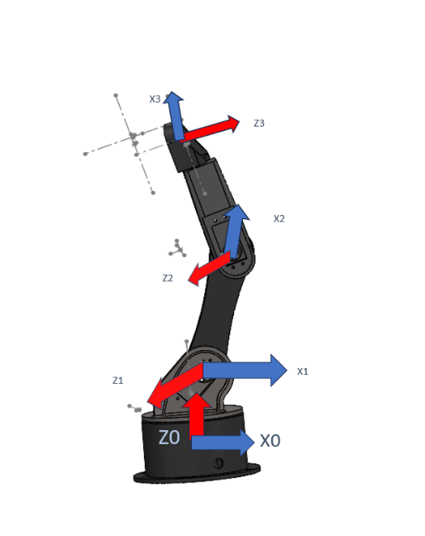
- Methodology
The robotic manipulator in this report has three joints, and its structure is represented by Denavit-Hartenberg (DH) parameters. The DH parameters define the position and orientation of each link in the manipulator relative to the previous link. The table below shown the parameter values as this:
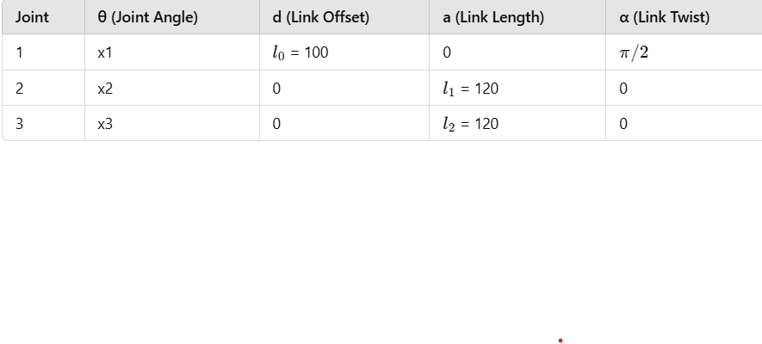
The final end-effector position is obtained from the cumulative transformation matrix​ by extracting the position values in the last column of the matrix.
The forward kinematics function calculates the end-effector position as (x, y, z) based on the input joints
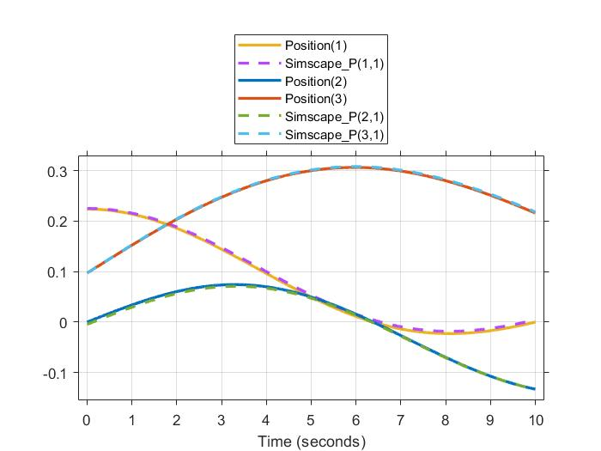

Inverse kinematics is approached iteratively using the Newton-Raphson method. This method adjusts joint angles to minimize the difference between the current end-effector position and the desired position.
- Initial Guess: Start with an initial guess for joint angles.
- Forward Kinematics: Compute the current end-effector position based on the guessed joint angles.
Jacobian Inverse: Calculate the Jacobian inverse to relate changes in end-effector position to changes in joint angles.
The inverse kinematics function iteratively updates joint angles and outputs the values that will position the end-effector at (x, y, z) desired.
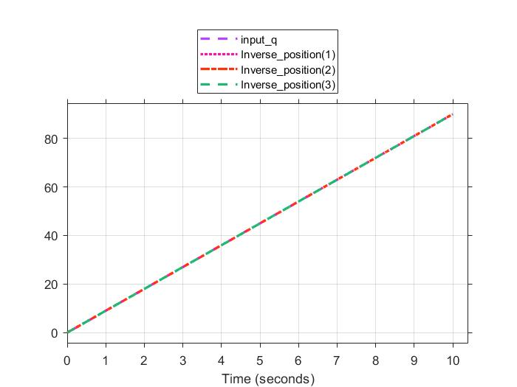

To model the manipulator, the DH convention was applied to define the relative transformations between adjacent links based on joint angles and link lengths:
- Link lengths: Constants were specified for the three links of the manipulator.
- DH Table: Each row in the DH table contains four parameters for each joint:
  - θ (joint angle)
  - d (offset along the previous Z-axis to the common normal)
  - a (length of the common normal)
  - α (angle between the previous Z-axis and the current Z-axis)
Using these parameters, transformation matrices for each link were computed iteratively.
3. Transformation Matrix Computation
Each joint transformation was calculated based on its DH parameters:
- For each joint, a transformation matrix T was computed to represent the position and orientation of the current link relative to the previous link.
- These transformations were multiplied sequentially to find the position of each joint in the base frame.
4. Calculation of the Jacobian Matrix
The Jacobian matrix, which maps joint velocities to the end-effector's linear and angular velocities, was constructed:
- Linear Velocity Jacobian (Jv): Each column in the linear part of the Jacobian was calculated as the cross product of the joint axis with the position vector from the joint to the end-effector.
- Angular Velocity Jacobian (Jw): For revolute joints, the angular velocity part was represented by the joint axis.
- The combined Jacobian J was formed by stacking Jv and Jw vertically.
With the Jacobian matrix computed, the forward velocity kinematics were determined:
- By multiplying the Jacobian matrix J with a vector of joint velocities q̇, the linear and angular velocity components of the end-effector were obtained.
- This gives the resulting end-effector velocity V_F for a given set of joint velocities.
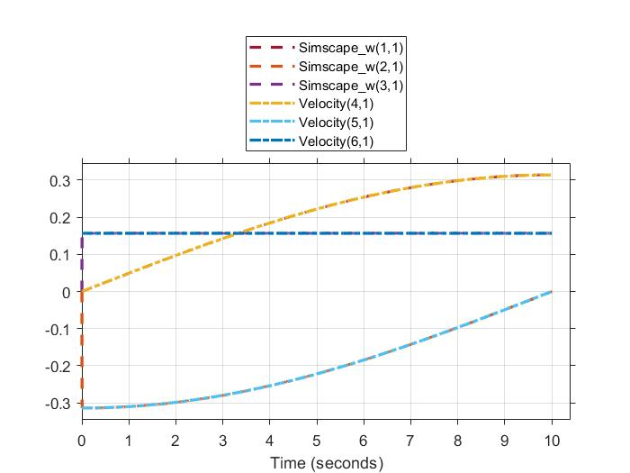

To find the joint velocities required to achieve a specified end-effector velocity:

- The Moore-Penrose pseudo-inverse of the Jacobian J was computed. This allows for solving the inverse kinematics problem when J is not square or in cases where it may not be invertible.

- By multiplying the pseudo-inverse J_inv with the desired end-effector velocity vector V_F, the required joint velocities q̇ were obtained.
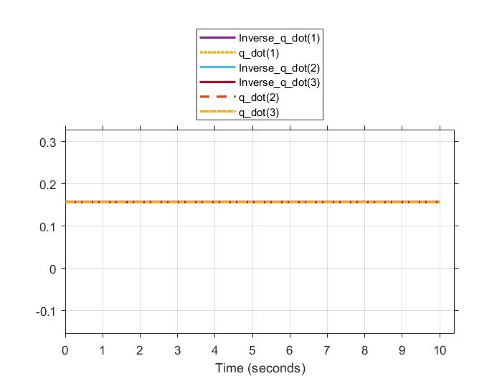


- Hardware
we assembled the physical robotic manipulator and tested the servo motors using Arduino code to ensure proper functionality. The Arduino code and assembly details have been documented in the milestone3 folder on our GitHub repository.
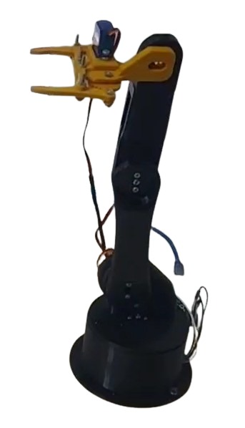
- Trajectory Tracking
Joint space trajectory planning involves creating smooth motion profiles for each robotic joint to transition from an initial to a final position. This process uses higher-order polynomials, such as quintic polynomials, to ensure smooth transitions while considering constraints like velocity and acceleration at the start and endpoint. The steps include defining start and end positions, determining motion duration, using inverse kinematics to compute joint requirements, and formulating polynomial equations based on these parameters to achieve seamless movement. The equations changes during different intervals every few seconds the eq . example , in time 0 it began the first angles to be zeros then from 0 to 5 q1 = 10.8*t²-1.44* t³;
q2 = q1;
q3 = 0;
then from time 5 to 6
q1 = 90;
q2 = 90;
q3 = 0;
them from time 6 to 11
u=u-6;
q1 = 90-10.8*t²+1.44* t³;
q2 = 90-6.48*t²+0.864* t³;
q3 = 5.76*t²-0.768* t³;
then from time 11 to 15
q1 = 0;
q2 = 36;
q3 = 48;
then from 15 to 20
u=u-15;
q1 = 10.8*t²-1.44* t³;
q2 = 36;
q3 = 48 -3.36*t²+0.448* t³;
from time 20-23
u=u-20;
q1 = 90;
q2 = 36;
q3 = 20 +9.3333*t²-2.0741* t³;
from time 23 to 26
q1 = 90;
q2 = 36;
q3 = 48;
from 26 to 29
u=u-26
q1 = 90;
q2 = 36+18*t²-4*t³;
q3 = 48 -16*t²+3.5556* t³;
the rest of equations are represented in the MATLAB code these codes from 0s to 65 seconds the above is the first half of the trajectory the above graph shows the trajectory of it through time.
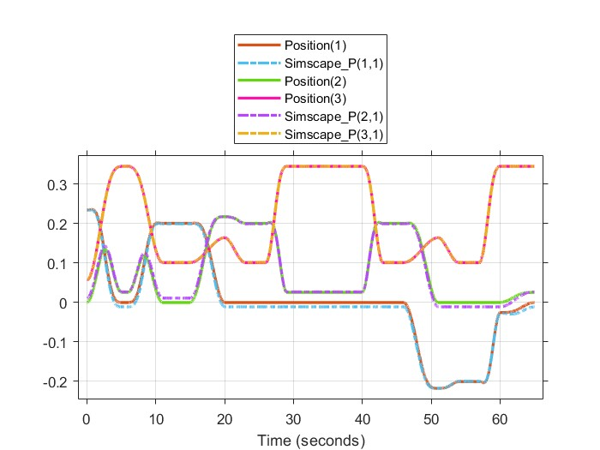
Then we had to double-check Simulink with Copilia sim files the arm was designed and exported to Copilia sim and a python code was written to move to the needed path and the video of it in appendix A also the below image shows the arm itself in copilia sim
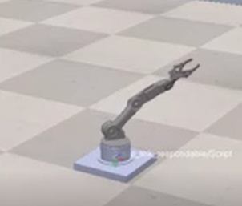

- Collaboration with other team
This was inspired to avoid tedious work of stamping papers or other objects this could save money for a company. our robot is used to pick from a pile the video qr code in apendex A and place the wooden part of 4x4 cm to a certain place 20 cm away from the base and the other robot extend to 10 cm to stamp but we made both arms with respect to a single global frame and we choose a single point in the frame to make both arms reach the point was mostly the middle of the box as taught in our tutorials .to be easily understood an image below will demonstrate everything and the video in the appendix shows how it moves
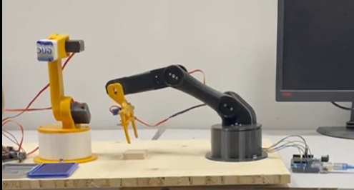

- Results and Conclusion
the generated graphs indicate a strong alignment between the kinematic calculations and the results from Simscape. This agreement validates the accuracy of the Jacobian-based approach for computing position and velocity kinematics, affirming that the theoretical model effectively matches the simulation outcomes. This alignment underscores the robustness of the mathematical model and its practical reliability for real-world applications. Furthermore, the arm had zero to negligible jurk as it doesn’t vibrate in the air.

Appendix A


